

International School

**Capstone Project 2**

CMU-SE 451

**User Interface Design Document**

**Version 2.2**

**Date:** 13/04/2023

**Craft Village Pollution Monitor System**

**Submitted by**

**Ca, Van Cong Le**

**Huy, Bui Duc**

**Phuc, Hua Hoang**

**Trung, Nguyen Thanh**

**Nhan, Huynh Ba**

**Approved by**

**Ph.D. Nguyen Thanh Binh**

**Proposal Review Panel Representative:**

Name Signature Date

**Capstone Project 2 - Mentor:**

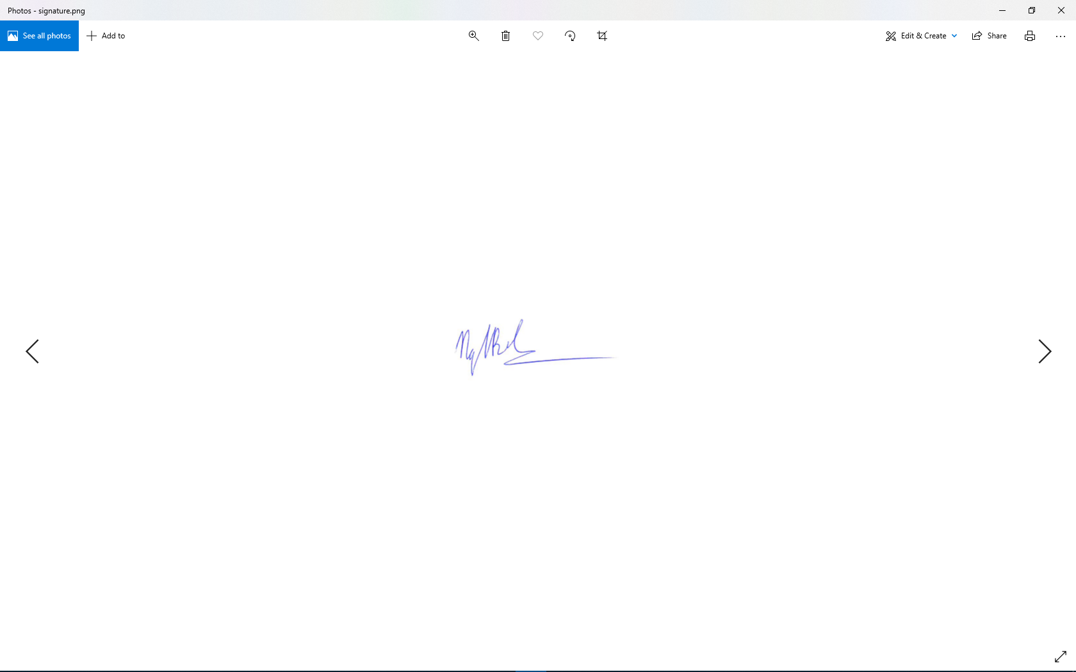

Name Signature Date

**PROJECT INFORMATION**

|  |  |  |  |
| --- | --- | --- | --- |
| **Project acronym** | CVPMS | | |
| **Project Title** | Craft Village Pollution Monitor System | | |
| **Start Date** | 01/03/2023 | **End Date** | 15/05/2023 |
| **Lead Institution** | International School, Duy Tan University | | |
| **Project Mentor** | Ph.D. Thanh Binh, Nguyen | | |
| **Scrum master / Project Leader & contact details** | Ca, Van Cong Le  *Email:* cascabusiness@gmail.com  *Tel:* 0352707895 | | |
| **Partner Organization** |  | | |
| **Project Web URL** | [*https://github.com/Casca113s2/craft-village-pollution-monitor-system*](https://github.com/Casca113s2/craft-village-pollution-monitor-system) | | |
| **Team members** | **Name** | **Email** | **Tel** |
| 25211207666 | Ca, Van Cong Le | [cascabusiness@gmail.com](http://cascabusiness@gmail.com) | 0352707895 |
| 25211215894 | Huy, Bui Duc | [duchuyltt122@gmail.com](http://duchuyltt122@gmail.com) | 0818648090 |
| 25211204084 | Phuc, Hua Hoang | [phuchuho0402@gmail.com](http://phuchuho0402@gmail.com) | 0905639682 |
| 25211215133 | Trung, Nguyen Thanh | [nguyenttrung2601@gmail.com](http://nguyenttrung2601@gmail.com) | 0774496838 |
| 25211203702 | Nhan, Huynh Ba | [nhanhuynh1409@gmail.com](mailto:nhanhuynh1409@gmail.com) | 0935430785 |

DOCUMENT NAME

|  |  |  |  |
| --- | --- | --- | --- |
| **Document Title** | User Interface Design Document | | |
| **Author(s)** | Nguyen Thanh Trung | | |
| **Date** | 13/04/2023 | **File Name** | C2SE.01_CVPMS_User-Interface-Design-Document_v2.2.docx |

REVISION HISTORY

| **Version** | **Date** | **Comments** | **Author** | **Approval** |
| --- | --- | --- | --- | --- |
| 1.0 | 18/09/2022 | Create Document | Nguyen Thanh Trung |  |
| 1.1 | 05/10/2022 | Update Document (Survey page) | Nguyen Thanh Trung |  |
| 1.2 | 22/10/2022 | Create survey system (Survey page, Register page) | Nguyen Thanh Trung |  |
| 1.3 | 08/11/2022 | Create survey system (Survey page, Homepage) | Nguyen Thanh Trung |  |
| 2.0 | 14/03/2023 | Create Document | Nguyen Thanh Trung |  |
| 2.1 | 29/03/2023 | Update Document (Household, Local Authority, Admin) | Nguyen Thanh Trung |  |
| 2.2 | 13/04/2023 | Update Document (Map, view survey, Edit layout, …etc) | Nguyen Thanh Trung |  |

**Approve Document:** Sign in to approve document

|  |  |  |  |
| --- | --- | --- | --- |
| **Mentor** | Binh, Nguyen Thanh | Date | 13/04/2023 |
| Sign |  |
| **Scrum Master** | Ca, Van Cong Le | Date | 13/04/2023 |
| Sign |  |
| **Scrum Member** | Huy, Bui Duc | Date | 13/04/2023 |
| Sign |  |
| **Scrum Member** | Phuc, Hua Hoang | Date | 13/04/2023 |
| Sign |  |
| **Scrum Member** | Trung, Nguyen Thanh | Date | 13/04/2023 |
| Sign |  |
| **Scrum Member** | Nhan, Huynh Ba | Date | 13/04/2023 |
| Sign |  |

**Table Of Contents**

1. Introduction 7

1.1. Purpose 7

1.2. Scope 7

2. List of User Interface 7

2.1. Local Authority 7

2.2. Household 7

2.3. Admin 8

3. Describe the User Interface 8

3.1. Local Authority 8

3.1.1. Local Authority Home Page 8

3.1.2. Detail Declaration 10

3.1.3. Pollution Craft Village Map Data Page 11

3.2. Household 12

3.2.1. Survey Page 12

3.3. Admin 14

3.3.1. Create New Local Authority Page 14

Table Of Figures

**Figure 1.** UI of Local Authority Home Page 8

**Figure 2.** UI of Local Authority Home Page Below 9

**Figure 3.** UI of Detail Declaration 10

**Figure 4.** UI of Detail Declaration 10

**Figure 5.** UI of Pollution Craft Village Map Data Page 11

**Figure 6.** UI of Survey Page 12

**Figure 7.** UI of Survey Page 13

**Figure 8.** UI of Create New Local Authority Page 14

Table Of Tables

**Table 1.** List of Local Authority User Interface 7

**Table 2.** List of Household User Interface 7

**Table 3.** List of Admin User Interface 8

**Table 4.** Elements of UI Local Authority Home Page 8

**Table 5.** Elements of UI Local Authority Home Page Below 9

**Table 6.** Elements of UI Detail Declaration 10

**Table 7.** Elements of UI Pollution Craft Village Map Data Page 11

**Table 8.** Elements of UI Survey Page 12

**Table 9.** Elements of UI Survey Page 13

**Table 10.** Elements of UI Create New Local Authority Page 14

# **Introduction**

## Purpose

* This document helps to better understand the interface of the Comment Scraper Tool, detailed specification components and function of the system.
* With this document, the development team can understand detail the structure and composition to create a consistent and complete system.

## Scope

* Overview of the stages and modules of the system.
* Create complete interfaces and describe them clearly.

# List of User Interface

## Local Authority

**Table 1.** List of Local Authority User Interface

|  |  |  |
| --- | --- | --- |
| **User Interface ID** | **UI Name** | **Description** |
| UI-01 | Local Authority Home Page | This page to see statistics about craft villages |
| UI-02 | Detail Declaration Page | This page displays detailed production information of the craft village |
| UI-03 | Pollution Craft Village Map Data Page | This page displays a map of polluted craft villages and location information |

## Household

**Table 2.** List of Household User Interface

|  |  |  |
| --- | --- | --- |
| **User Interface ID** | **UI Name** | **Description** |
| UI-04 | Survey Page | This page allows household heads to register their craft villages or register new craft villages if that craft village does not exist in the database |

## Admin

**Table 3.** List of Admin User Interface

|  |  |  |
| --- | --- | --- |
| **User Interface ID** | **UI Name** | **Description** |
| UI-05 | Create New Local Authority Page | This page to create a new local authority account. |

# Describe the User Interface

## Local Authority

### Local Authority Home Page

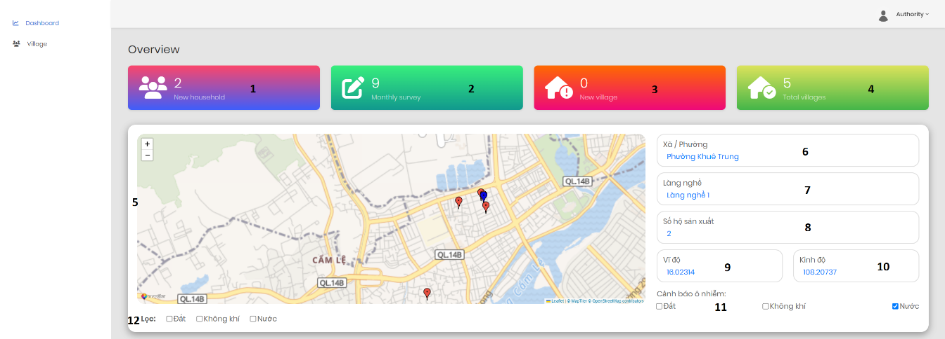

**Figure 1.** UI of Local Authority Home Page

**Table 4.** Elements of UI Local Authority Home Page

|  |  |  |  |  |
| --- | --- | --- | --- | --- |
| From | Condition | Control Type | Target | Notes |
| 1 | View | Lable | Display the number of new households |  |
| 2 | View | Lable | Display the number of surveys |  |
| 3 | View | Lable | Display the number of the new village |  |
| 4 | View | Lable | Display the total village of the ward |  |
| 5 | View | Map | Display the polluted craft villages |  |
| 6 | View | Lable | Display ward address information |  |
| 7 | View | Lable | Display name of craft village |  |
| 8 | View | Lable | Display the number of households of village |  |
| 9 | View | Lable | Display the latitude of village |  |
| 10 | View | Lable | Display the longitude of village |  |
| 11 | View | Check Box | Warning about that kind of pollution in craft villages |  |
| 12 | Click | Check Box | Click to filter the type of contaminated craft village |  |

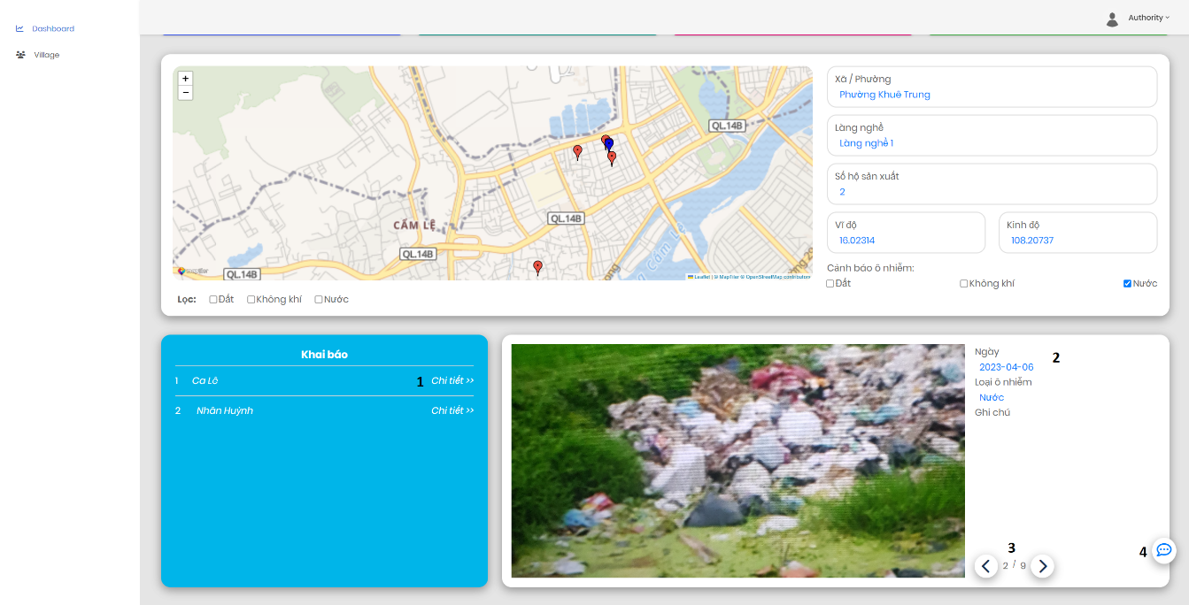

**Figure 2.** UI of Local Authority Home Page Below

**Table 5.** Elements of UI Local Authority Home Page Below

|  |  |  |  |  |
| --- | --- | --- | --- | --- |
| From | Condition | Control Type | Target | Notes |
| 1 | Click | Lable | Click to see detail information about the declaration |  |
| 2 | View | Lable | Display general information about the declaration |  |
| 3 | Click | Button | Click to see another declaration |  |
| 4 | Click | Button | Click to report site errors |  |

### Detail Declaration

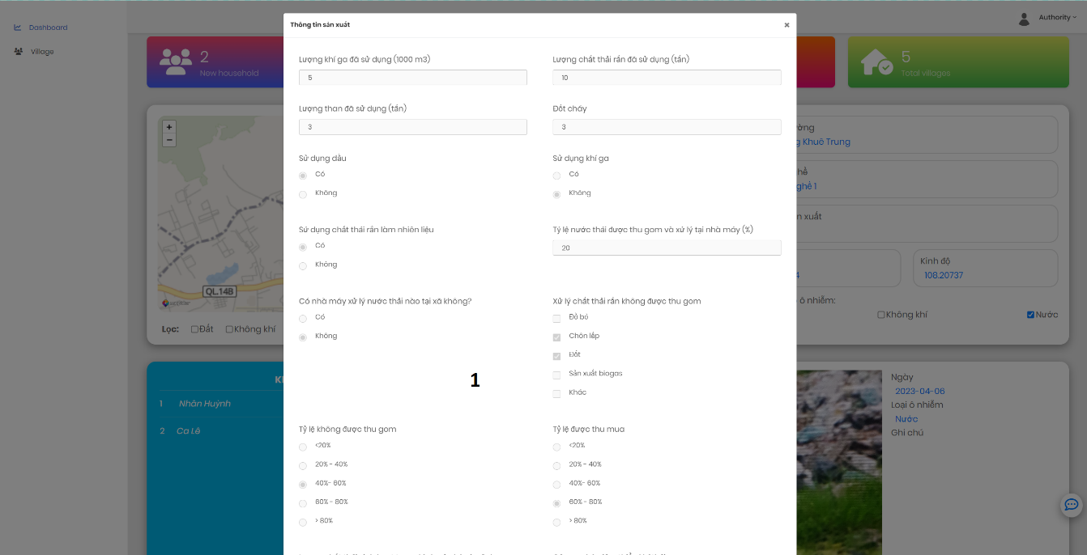

**Figure 3.** UI of Detail Declaration

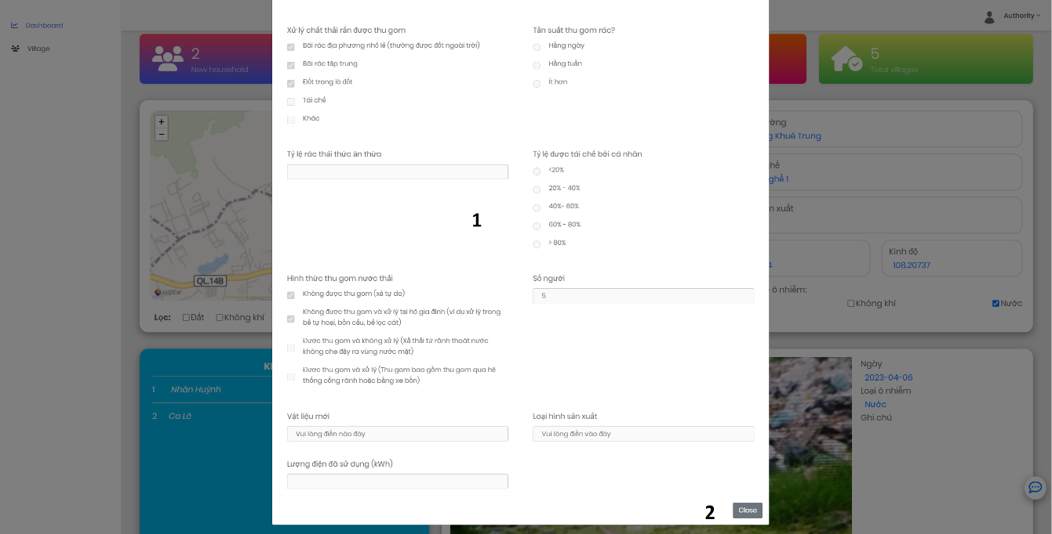

**Figure 4.** UI of Detail Declaration

**Table 6.** Elements of UI Detail Declaration

|  |  |  |  |  |
| --- | --- | --- | --- | --- |
| From | Condition | Control Type | Target | Notes |
| 1 | View | Lable | Display detailed information about the production of the craft village |  |
| 2 | Click | Button | Click to close detailed information |  |

### Pollution Craft Village Map Data Page

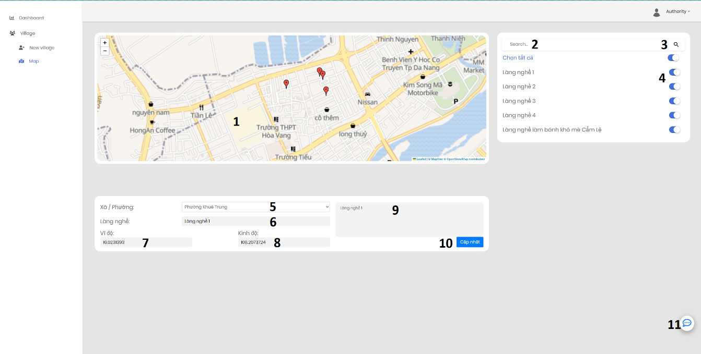

**Figure 5.** UI of Pollution Craft Village Map Data Page

**Table 7.** Elements of UI Pollution Craft Village Map Data Page

|  |  |  |  |  |
| --- | --- | --- | --- | --- |
| From | Condition | Control Type | Target | Notes |
| 1 | View | Map | Display the polluted craft villages |  |
| 2 | Input | Textbox | Enter the name of craft village |  |
| 3 | Click | Button | Click to view the location of craft village |  |
| 4 | Click | Button | Click to display or not display the location of the craft village on the map |  |
| 5 | Click | DropDownList | Click to select ward of village |  |
| 6 | Input | Textbox | Enter the name of village |  |
| 7 | Input | Textbox | Enter latitude |  |
| 8 | Input | Textbox | Enter longitude |  |
| 9 | View | Texbox | Display the name of village |  |
| 10 | Click | Button | Click to update information about village |  |
| 11 | Click | Button | Click to report site errors |  |

## Household

### Survey Page

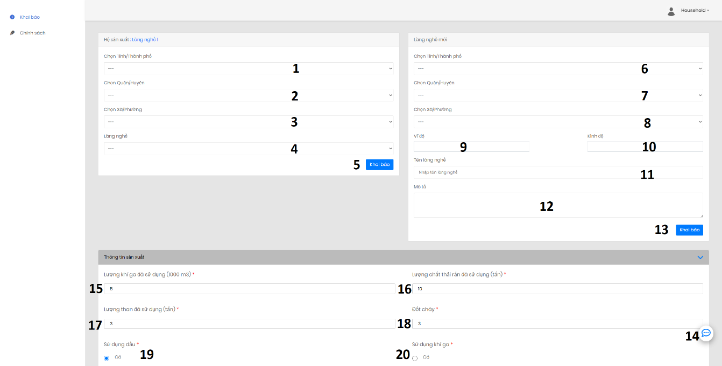

**Figure 6.** UI of Survey Page

**Table 8.** Elements of UI Survey Page

|  |  |  |  |  |
| --- | --- | --- | --- | --- |
| From | Condition | Control Type | Target | Notes |
| 1 | Click | DropDownList | Click to select province/city |  |
| 2 | Click | DropDownList | Click to select district |  |
| 3 | Click | DropDownList | Click to select ward |  |
| 4 | Click | DropDownList | Click to select village |  |
| 5 | Click | Button | Click to declare a new craft village |  |
| 6 | Click | DropDownList | Click to select province/city |  |
| 7 | Click | DropDownList | Click to select district |  |
| 8 | Click | DropDownList | Click to select ward |  |
| 9 | Input | Textbox | Enter the latitude |  |
| 10 | Input | Textbox | Enter the longitude |  |
| 11 | Input | Textbox | Enter the name of village |  |
| 12 | Input | Textbox | Enter a description of the craft village |  |
| 13 | Click | Button | Click to declare a new craft village |  |
| 14 | Click | Button | Click to report site errors |  |
| 15 | Input | Textbox | Enter amount of gas used |  |
| 16 | Input | Textbox | Enter amount of solid waste used |  |
| 17 | Input | Textbox | Enter amount of coal used |  |
| 18 | Input | Textbox | Enter amount of combustion used |  |
| 19 | Click | Radio Button | Click to declare whether to use oil or not |  |
| 20 | Click | Radio Button | Click to declare whether to use gas or not |  |

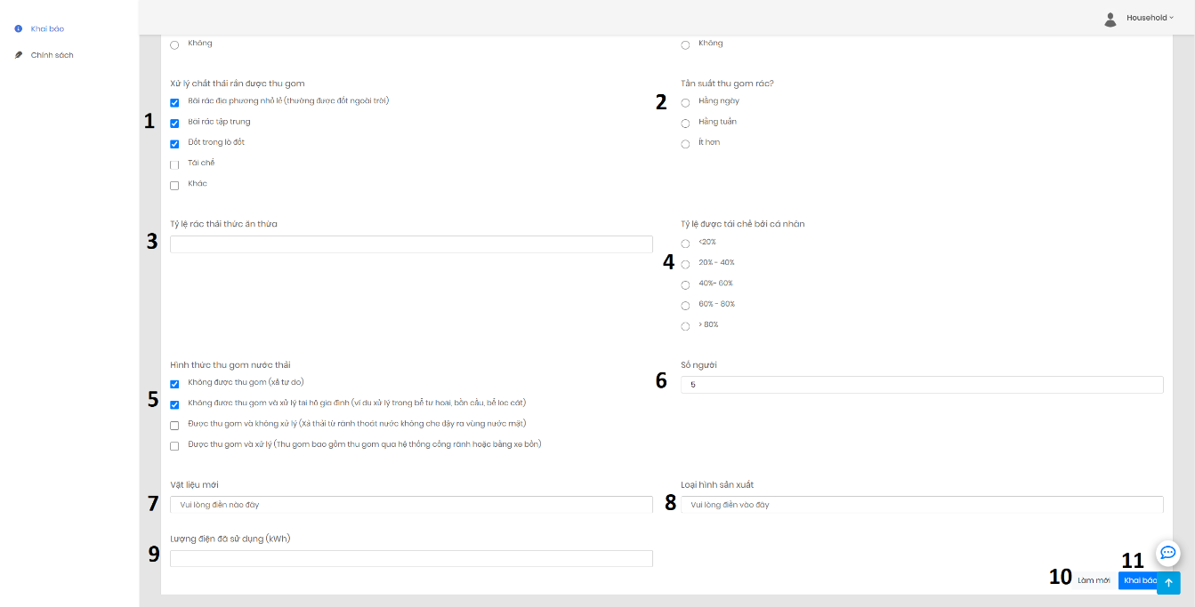

**Figure 7.** UI of Survey Page

**Table 9.** Elements of UI Survey Page

|  |  |  |  |  |
| --- | --- | --- | --- | --- |
| From | Condition | Control Type | Target | Notes |
| 1 | Click | Check Box | Click to choose how to collect solid waste |  |
| 2 | Click | Radio Button | Click to select solid waste collection frequency |  |
| 3 | Input | Textbox | Click to rate of food waste |  |
| 4 | Click | Radio Button | Click to select village |  |
| 5 | Click | Check Box | Click to declare a new craft village |  |
| 6 | Input | Textbox | Enter the longtitude |  |
| 7 | Input | Textbox | Enter the latitude |  |
| 8 | Input | Textbox | Enter the name of village |  |
| 9 | Input | Textbox | Enter a description of the craft village |  |
| 10 | Click | Button | Click to refresh the information just filled |  |
| 11 | Click | Button | Click to declare detail information |  |

## Admin

### Create New Local Authority Page

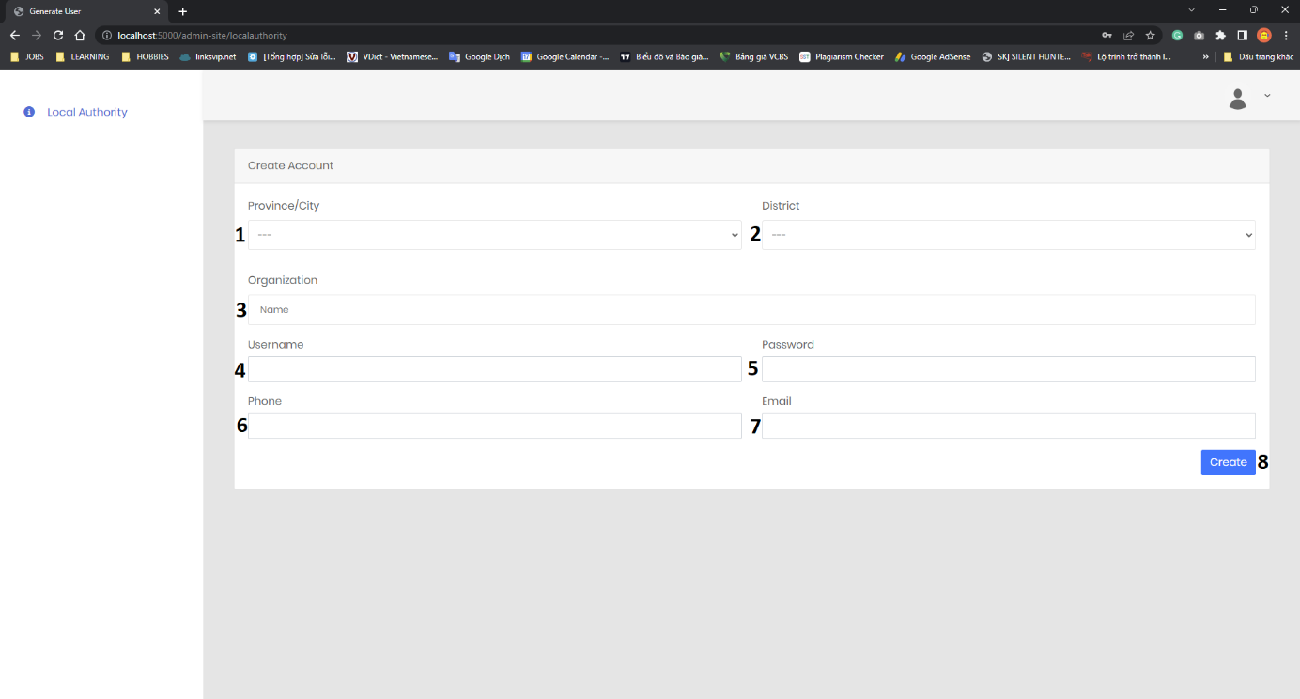

**Figure 8.** UI of Create New Local Authority Page

**Table 10.** Elements of UI Create New Local Authority Page

|  |  |  |  |  |
| --- | --- | --- | --- | --- |
| From | Condition | Control Type | Target | Notes |
| 1 | Click | DropDownList | Click to select province/city |  |
| 2 | Click | DropDownList | Click to select district |  |
| 3 | Input | Textbox | Enter the name of organization |  |
| 4 | Input | Textbox | Enter the email address |  |
| 5 | Input | Textbox | Enter the phone number |  |
| 6 | Click | Button | Click to create a new local authority |  |
| 7 | Click | Check Box | Click to select the questions that the household is asked to answer |  |
| 8 | Scroll | Scroll Bar | Scroll to select question |  |
| 9 | Click | Button | Click to save the questionnaire |  |
| 10 | Click | Button | Click to download dataset to train AI |  |